How to register for the CSLL Columbus Day Tournament.

1-Visit www.csll.net and register to create a new account.
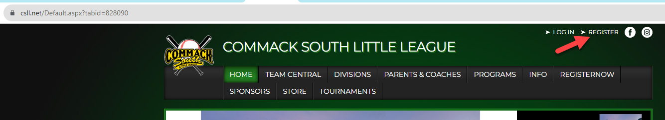
2-Enter your email address and create a password.
3- Validate the email that was sent to your email address.

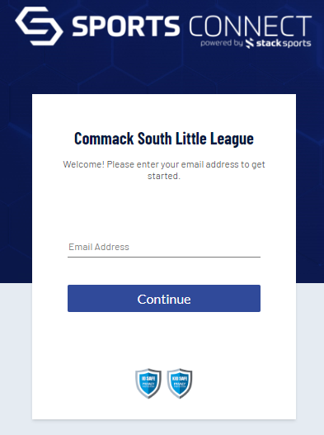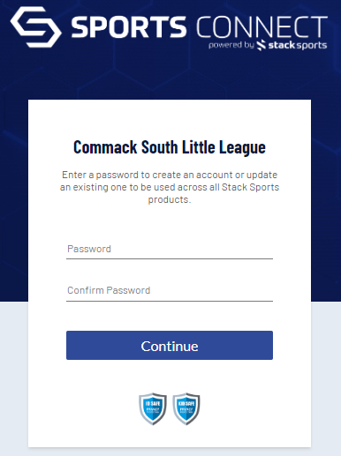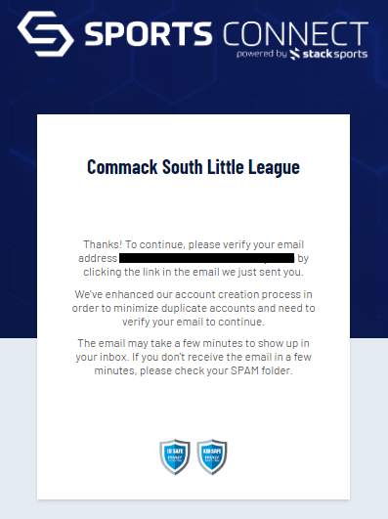

4- Select the Programs available button and then select the 10 Columbus tourney
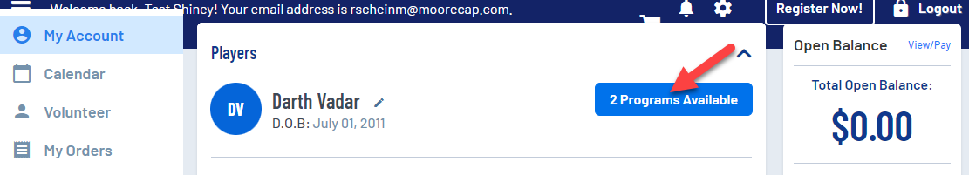

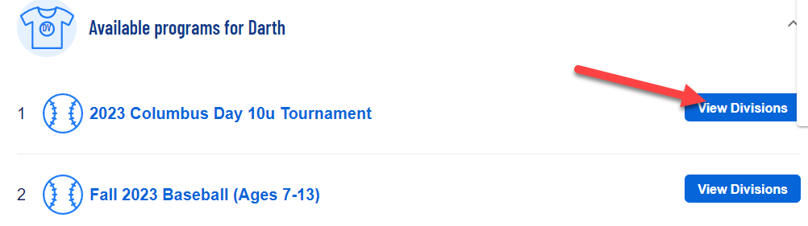
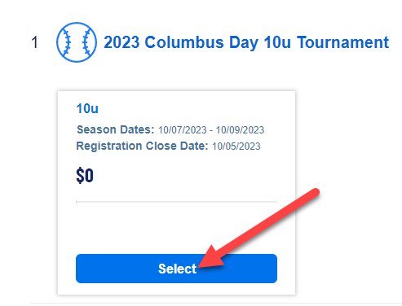

6- Fill out all arrowed spots and make sure you selected no for the team code.
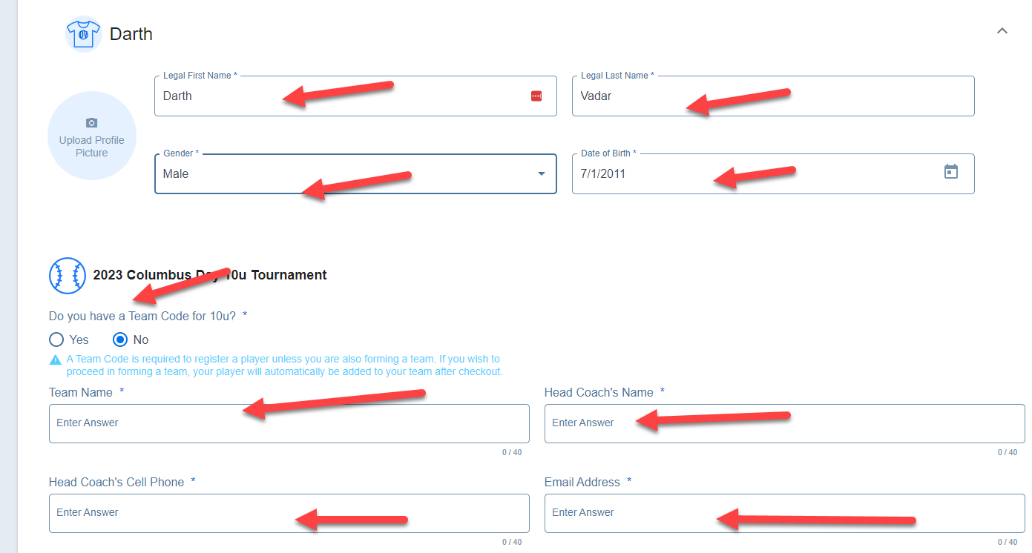

7- select the Head Coach option sign up on the left side of this picture. You wil have to fill out a few more fields even though they might be duplicates. Then hit Continue.
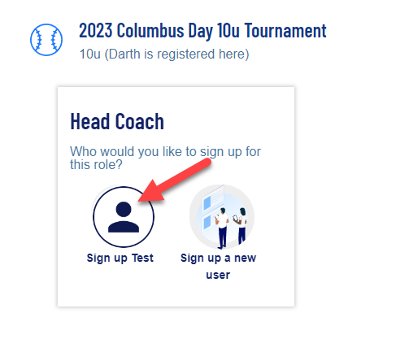
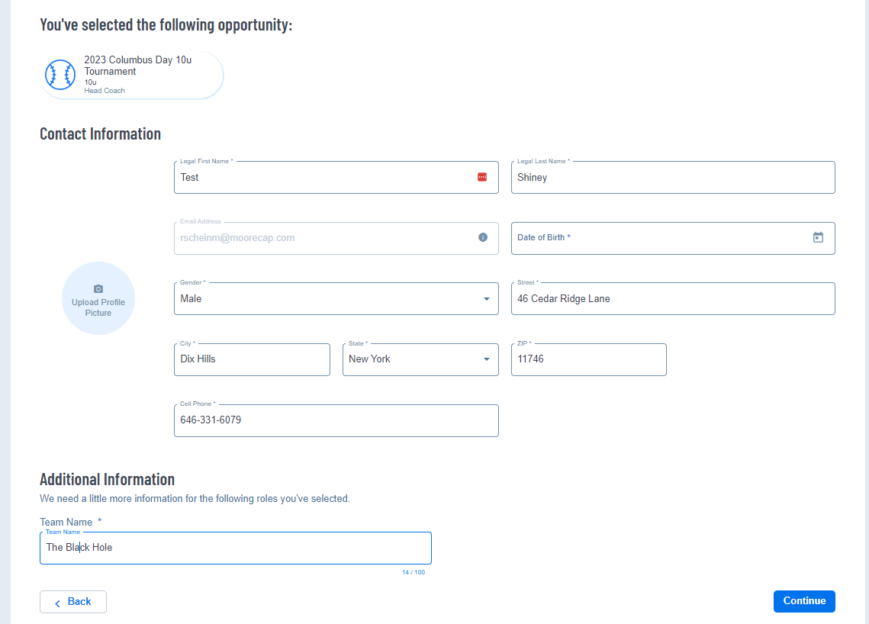
8- You can skip over the merchandise store.

8- Confirm you only have one entry that is reflecting the cost of the tournament.
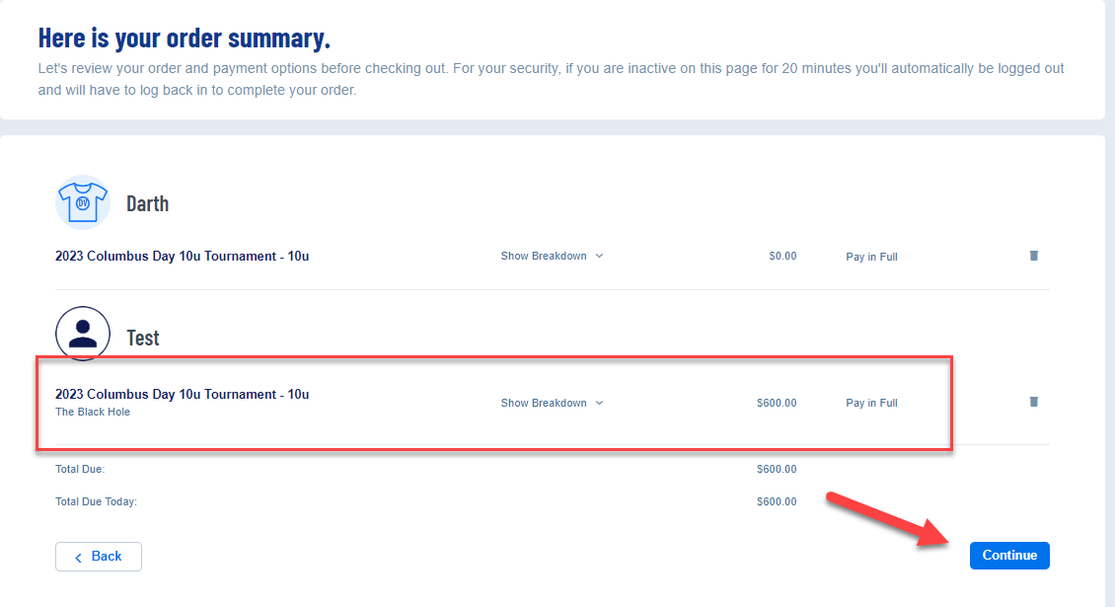
9- Now finalize your payment by inputting you credit card information. You will receive an email confirming you successfully register for the tournament.
